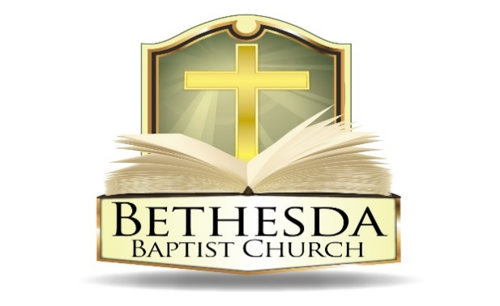
Covenant Partner News
Sunday, November 23, 2025
Volume 5 Issue 47

RECURRING EVENTS

Hour of Power & Bible Study No Bibles Study; Bible Study resumes Tuesday, December 2
Each Tuesday at 6:00pm followed by Bible Study at 7:00pm via *ZOOM:
https://us02web.zoom.us/j/83096366206?pwd=J7wZ8bwAcBA1snP5SgRuYhW4E2DsU.1
Meeting ID: 830 9636 6206 Passcode: 199366
To use your cell phone or land line, *please dial: 1. 301. 715. 8592
Meeting ID: 830 9636 6206#; Passcode: 199366#
We encourage all members to submit prayer requests as the Holy Spirit leads by 12:00 Noon on Monday.

Open Praise Forum & Bible Study
Every Tuesday leading up to Communion Sunday at 6:00pm followed by
Bible Study at 7:00pm via ZOOM and on conference line referenced above. *

Bible Study Young Adult Edition
Each Wednesday at 7:30pm EST and 6:30pm CST via Zoom.
Register by text at 202-262-4476 or email kgoady07@gmail.com.

Men’s Prayer Hour
Each Wednesday at 9:00pm via conference call: 1.717.908.1972; Access 875378#

Women’s Prayer Hour resume January 2026
Each 4th Saturday at 9:00am via conference call: 1.605.313.5143; Access code 654522#

Questions and Answers
Held each 4th Sunday at 6:00pm via conference call: 1.717.908.1972; Access code 875378#
Please submit your questions today by email to: SoulCare@Bethesdaweb.org or in Q&A box located on the table outside of the church office.

Bible Study No Bibles Study; Bible Study resumes Thursday, December 4
Each Thursday at 12:00 Noon via conference call: 1.717.908.1972; Access code 875378#

THIS WEEK EVENTS

In memory of Sister Lillie Cook the Church Office will be closed on
Monday, November 24th and will resume on Tuesday, November 25th

Thursday, November 27
10:00am Thanksgiving Day Service

Friday, November 28
No Activity at the Church

ANNOUNCEMENTS

Sunday School Ministry Meeting 6:30pm Thursday, December 4
Good News Club 6:00pm Friday, December 5
DC Aglow Ministry 10:00am Saturday, December 6
Flower Guild Ministry Meeting 11:00am Saturday, December 6
Voices of Bethesda Fellowship Meeting 6:30pm Wednesday, December 10
Christian Education Ministry Meeting 6:30pm Thursday, December 11
Good News Club 6:00pm Friday, December 12

DECISION DAY
Today we will observe Decision Day at Bethesda. This will be an opportunity for you to become a tither, increase your tithing or join a ministry. 1 Peter 4:10 says, "As each one has received a gift, minister to one another as good stewards of the manifold grace of God." Please complete your Decision Day form and place it in the basket at the back of the church as you leave. Your commitment is an important step in faith.

"Commit your work to the Lord, and your plans will be established."
— Proverbs 16:3

THANKSGIVING OFFERING - GIVE TO STRENGTHEN OUR COMMUNITY
As we gather in gratitude this Thanksgiving, we invite you to make a Thanksgiving offering to support our community. Your gift, no matter the size, helps provide food for families, warmth for the elderly, and hope for those facing hardship. It’s a chance to turn gratitude into action.

Let this season be marked not only by what we receive, but by what we give. Together, we can ensure that everyone in our community feels the embrace of care and the promise of a better tomorrow.
Give thanks. Give hope. Give today.

BETHESDA FOOD PANTRY
Dear Church Family, Our food pantry is in need of replenishment, and we humbly ask for your support in helping us restock it with non-perishable items to serve those in our community who are struggling. As we are reminded in Proverbs 19:17, “Whoever is generous to the poor lends to the Lord, and He will repay him for his deed.” Your contributions, no matter how small, are a powerful act of love and faith. Let us come together to be the hands and feet of Christ in this season of need.

ANNOUNCEMENTS (CONTINUED):

CHRISTMAS OUTREACH
We have two opportunities to be blessings to others this Christmas. Both of these outreaches give us the opportunity to express God’s love to a child that may be the only gift he or she gives. Operation Christmas Child shoeboxes will be handed out after church this Sunday for those of you who wish to participate.
These boxes will be sent by Samaritan’s Purse to children all over the world. We also want to be a blessing to Ivy City, our Jerusalem. For children in Ivy City, you may take an unused shoe box and fill it with the same contents listed below, then wrap that box and drop it off at Bethesda. The deadlines are as follows:

- Operation Christmas Boxes—Sunday, November 16
- Ivy City Boxes—Sunday, December 13

Sample Contents
- Toys
- Jump ropes and yo-yos
- Soccer ball with pump
- Hat and gloves
- Toothbrushes
- Socks
- Pens, pencils, crayons, and markers
- Solar calculators
- Hair accessories
- Flashlights
- A note and photo

Do not include soap, candy, toothpaste, gum, used or damaged items, scary or war-related items, seeds, food, liquids or lotions, medications or vitamins, breakable items or glass containers, aerosol cans.

ANNOUNCEMENTS (CONTINUED):

CHRISTMAS IN THE PARK
The EOU is planning a Christmas in the Park. The celebration of The Birth of Jesus will be Happening Saturday, December 20, 2025. (11:00 AM TO 2:00 PM)
We are looking for volunteers to serve on the Planning Committee. The first planning meeting will be a teleconference call on the church's number on Monday, December 1, 2025, at 6:00 pm. Please give your name to the Church's office Staff, Sisters Adrilla Howard or Jennie Sanders by November 30, 2025. This event is Donors sponsored. The Good News of Jesus's Birth will go forward.

2026 CONTRIBUTION ENVELOPES
Offering envelopes are ready for pick up today or during the church office hours 9:00 am – 4:00 pm, Monday through Wednesday. Envelopes are on the table in front of the Church office.

SUNDAY SCHOOL ON DECEMBER 7TH
Join the Sunday school on December 7th for a video presentation by Tony Evans on the state of America. All adult Sunday school classes will meet in the sanctuary and those online can join by telephone. Thank you for your participation.

ANNOUNCEMENTS (CONTINUED):

105th Anniversary
Bethesda Baptist Church
God’s Faithfulness Through The Ages
March 1-March 22, 2026

Updates

- The Anniversary Banquet is March 21, 2026, at the Doubletree Hotel in Largo, MD. Donation is $112.00 per person. Payment #1 is due December 14th in the amount of $40.00. Payments may be mailed, given at church or on-line at Bethesdaweb.org under “Special offering.”

Lord, you have been our dwelling place in all generations
Psalm 90:1

