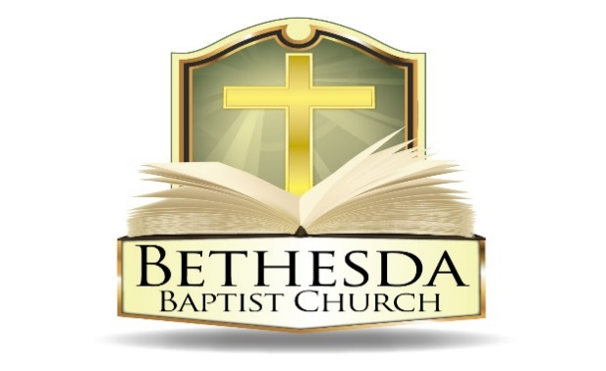
Covenant Partner News
Sunday, November 2, 2025
Volume 5 Issue 43

RECURRING EVENTS

Hour of Power & Bible Study
Each Tuesday at 6:00pm followed by Bible Study at 7:00pm via *ZOOM:
https://us02web.zoom.us/j/83096366206?pwd=J7wZ8bwAcBA1snP5SgRuYhW4E2DsU.1
Meeting ID: 830 9636 6206 Passcode: 199366
To use your cell phone or land line, *please dial: 1. 301. 715. 8592
Meeting ID: 830 9636 6206#; Passcode: 199366#
We encourage all members to submit prayer requests as the Holy Spirit leads by 12:00 Noon on Monday.

Open Praise Forum & Bible Study
Every Tuesday leading up to Communion Sunday at 6:00pm followed by
Bible Study at 7:00pm via ZOOM and on conference line referenced above. *

Bible Study Young Adult Edition
Each Wednesday at 7:30pm EST and 6:30pm CST via Zoom.
Register by text at 202-262-4476 or email kgoady07@gmail.com.

Men’s Prayer Hour
Each Wednesday at 9:00pm via conference call: 1.717.908.1972; Access 875378#

Women’s Prayer Hour
Each 4th Saturday at 9:00am via conference call: 1.605.313.5143; Access code 654522#

Questions and Answers
Held each 4th Sunday at 6:00pm via conference call: 1.717.908.1972; Access code 875378#
Please submit your questions today by email to: SoulCare@Bethesdaweb.org or in Q&A box located on the table outside of the church office.

Bible Study
Each Thursday at 12:00 Noon via conference call: 1.717.908.1972; Access code 875378#

THIS WEEK EVENTS

Monday, November 3
6:30pm EOU Planning Meeting via conference call: 1.717.908.1972; Access code 875378#

Friday, November 7
6:00pm Good News Club - email: gncbethesda1@gmail.com, Rooms 118 and 120

Saturday, November 8
9:00am Leadership Training (in-person)
10:30am Combined Choir Rehearsal, Room 120

ANNOUNCEMENTS

Doris Jordan Memorial Library Meeting 11:00am Monday, Nov. 10
Memorial Program Meeting 5:30pm Monday, Nov. 10
Seniors’ Ministry Business Meeting 11:00am Wednesday, Nov. 12
Good News Club 6:00pm Friday, Nov. 14
Missionary Ministry Meeting 10:00am Saturday, Nov. 15
Spiritual Friends Network Ministry Meeting 3:30pm Saturday, Nov. 15

BAPTIST WOMEN’S WORLD DAY OF PRAYER
The Missionary Ministry of Mount Pleasant Baptist Church cordially invites you to be Guest of Honor at the Baptist Women’s World Day of Prayer (75 Years of Impact, 1950-2025), on Monday, November 3, 2025, from 11:00 a.m. to 2:00 p.m. Join us as we gather from near and far, and pray one for another. This year’s theme is “Living the Good News.” Our scripture will be: ““The Spirit of the Lord is on me, because he has anointed me to proclaim good news to the poor. He has sent me to proclaim freedom for the prisoners and recovery of sight for the blind, to set the oppressed free, to proclaim the year of the Lord’s favor.” Luke 4:18-19 (NIV). 1st Lady Sherl Streeter from Mt. Pleasant Baptist Church will be the Speaker. Bethesda Baptist Church women can attend without registering.

SENIORS’ MINISTRY
The Seniors’ Ministry invites you to “Count Your Birthday Blessings” at our upcoming Ministry Meeting on Wednesday, November 12, 2025. Please respond to our Birthday Celebration Invitation by Monday, November 10, 2025, at 4:00 p.m. You may RSVP by signing the Invitation List on the table outside the Church Office or by calling 202-635-2883, ext. 102. We look forward to celebrating with you.

ANNOUNCEMENTS (CONTINUED):

CHRISTMAS OUTREACH
We have two opportunities to be blessings to others this Christmas. Both of these outreaches give us the opportunity to express God’s love to a child that may be the only gift he or she gives. Operation Christmas Child shoeboxes will be handed out after church this Sunday for those of you who wish to participate These boxes will be sent by Samaritan’s Purse to children all over the world. We also want to be a blessing to Ivy City, our Jerusalem. For children in Ivy City, you may take an unused shoe box and fill it with the same contents listed below, then wrap that box and drop it off at Bethesda. The deadlines are as follows:
- Operation Christmas Boxes—Sunday, November 16
- Ivy City Boxes—Sunday, December 13

Sample Contents
- Toys
- Jump ropes and yo-yos
- Soccer ball with pump
- Hat and gloves
- Toothbrushes
- Socks
- Pens, pencils, crayons, and markers
- Solar calculators
- Hair accessories
- Flashlights
- A note and photo

Do not include soap, candy, toothpaste, gum, used or damaged items, scary or war-related items, seeds, food, liquids or lotions, medications or vitamins, breakable items or glass containers, aerosol cans

NEW SONG BIBLE FELLOWSHIP ANNIVERSARY
Bethesda has been invited to join
“ A Night of Thanksgiving and Praise to God: An Appreciation Gala honoring the ministry of Dr. Bernard Fuller.” This is in celebration of the church and pastor’s 35th Anniversary. The date is November 21, 2025, at 7:00 p.m., and the location is Martin's Crosswinds, 7400 Greenway Center Drive, Greenbelt, Maryland 20770, The guest speaker is Dr. Tony Evans and the cost is $125 per person. Dr. Fuller has been a special friend of Bethesda for many years through his teaching, preaching, counsel during our pastoral search process and mentoring of Pastor Thompson. Please see the church office if interested in attending.
ANNOUNCEMENTS (CONTINUED):

THANKSGIVING OFFERING - GIVE TO STRENGTHEN OUR COMMUNITY
As we gather in gratitude this Thanksgiving, we invite you to make a Thanksgiving offering to support our community. Your gift, no matter the size, helps provide food for families, warmth for the elderly, and hope for those facing hardship. It’s a chance to turn gratitude into action.

Let this season be marked not only by what we receive, but by what we give. Together, we can ensure that everyone in our community feels the embrace of care and the promise of a better tomorrow.
Give thanks. Give hope. Give today.

BETHESDA FOOD PANTRY
Dear Church Family, Our food pantry is in need of replenishment, and we humbly ask for your support in helping us restock it with non-perishable items to serve those in our community who are struggling. As we are reminded in Proverbs 19:17, “Whoever is generous to the poor lends to the Lord, and He will repay him for his deed.” Your contributions, no matter how small, are a powerful act of love and faith. Let us come together to be the hands and feet of Christ in this season of need.

