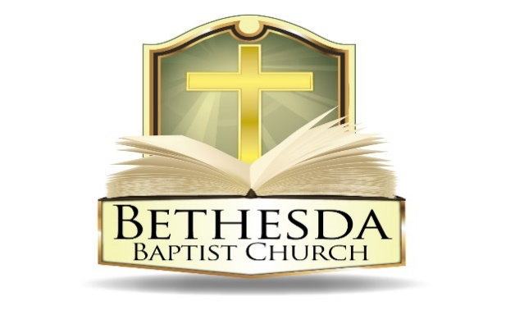
Covenant Partner News
Sunday, September 28, 2025
Volume 5 Issue 39

RECURRING EVENTS

Hour of Power & Bible Study
Each Tuesday at 6:00pm followed by Bible Study at 7:00pm via *ZOOM:
https://us02web.zoom.us/j/83096366206?pwd=J7wZ8bwAcBA1snP5SgRuYhW4E2DsU.1
Meeting ID: 830 9636 6206 Passcode: 199366
To use your cell phone or land line, *please dial: 1. 301. 715. 8592
Meeting ID: 830 9636 6206#; Passcode: 199366#
We encourage all members to submit prayer requests as the Holy Spirit leads by 12:00 Noon on Monday.

Open Praise Forum & Bible Study
Every Tuesday leading up to Communion Sunday at 6:00pm followed by
Bible Study at 7:00pm via ZOOM and on conference line referenced above. *

Bible Study Young Adult Edition
Each Wednesday at 7:30pm EST and 6:30pm CST via Zoom.
Register by text at 202-262-4476 or email kgoady07@gmail.com.

Men’s Prayer Hour
Each Wednesday at 9:00pm via conference call: 1.717.908.1972; Access 875378#

Women’s Prayer Hour
Each 4th Saturday at 9:00am via conference call: 1.605.313.5143; Access code 654522#

Questions and Answers
Held each 4th Sunday at 6:00pm via conference call: 1.717.908.1972; Access code 875378#
Please submit your questions today by email to: SoulCare@Bethesdaweb.org or in Q&A box located on the table outside of the church office.

Bible Study
Each Thursday at 12:00 Noon via conference call: 1.717.908.1972; Access code 875378#

THIS WEEK EVENTS

Monday, September 29
7:00pm Worshiping Nursery Meeting via conference call: 1-717-908-1972; Access code 875378#

Saturday, October 4
8:45am to 3:00pm Sharing Hope in Crisis, Sanctuary and Fellowship Hall
10:00am DC Aglow Ministry, Room 120

ANNOUNCEMENTS

Family and Friends Outreach Sunday 9:15am, Sunday, October 12
Fall Revival Wednesday – Fri., October 15 – 17
Good News Club 6:00pm, Friday, November 7

SHARING HOPE IN CRISIS CONFERENCE
We invite you to a special workshop, “Equipping God’s People for Ministry,” hosted by the Billy Graham Rapid Response Team (BG-RRT) at Bethesda on Saturday, October 4, 2025, from 8:45 am to 3:00 pm. Your presence would make a real difference as, together, we seek to support one another and our wider community in times of suffering, tragedy, and challenge.

This free, one-day seminar is designed for anyone with a caring heart who wants to offer meaningful emotional and spiritual care to people struggling with grief following a personal crisis.

During the seminar, you will learn practical tools and insights, including:
• Biblical View of Suffering
• Places of Grief
• Ministry of Hope
• Effects of Trauma
• Listening Skills
• What to Say and What Not to Say

We appreciate your compassion and willingness to serve, and we hope you’ll join us for this meaningful day of learning and encouragement. Together, we can make a positive impact on our church, families, and community.

Please register with the church office no later than today, September 29, 2025. There will be a mid morning snack but lunch will be”on your own”.

We hope to see you there!

ANNOUNCEMENTS (CONTINUED):

FAMILY AND FRIENDS OUTREACH SUNDAY
“To celebrate the importance of our family and friends, we will hold “Family and Friends Outreach Sunday” on Sunday, October 12, 2025. Please invite your friends and family to join us that day as we seek to grow in our relationship with Christ and to introduce others to our Lord and Savior. Our theme scripture is Psalm 78:5-8.

We will observe the Lord’s Supper during morning worship. During our regular Sunday School period, we will show a movie entitled, “Turn the Other Cheek,” and will conclude the celebration by distributing take home snacks. We have invitational bookmarks for you to distribute and sincerely hope you will use them to invite your family and friends to join us as we rejoice in the Lord together!”

DEAF MINISTRY
Basic American Sign Language (ASL) class forming soon. If you are interested, please sign the sign up sheet outside the church office and designate which day is best for you. The class will be held on a Tuesday or Wednesday at 10:30 a.m.

BETHESDA FOOD PANTRY
Dear Church Family, Our food pantry is in need of replenishment, and we humbly ask for your support in helping us restock it with non-perishable items to serve those in our community who are struggling. As we are reminded in Proverbs 19:17, “Whoever is generous to the poor lends to the Lord, and He will repay him for his deed.” Your contributions, no matter how small, are a powerful act of love and faith. Let us come together to be the hands and feet of Christ in this season of need.

BIBLE AND BIBLE RESOURCES DISPLAY
The Doris Jordan Bowman Memorial Library Committee invites you to browse the Bible and Bible Resources display in Room 118 (Scout room).

ANNOUNCEMENTS (CONTINUED):

NURSERY DURING SUNDAY SCHOOL HOUR
Do you love working with babies and toddlers? Loving them in the name of the Lord Jesus Christ? Come fulfill your passion in the nursery during the Sunday school hour. We are looking for workers to take care of babies to toddlers to young children up to age 5 in the nursery during the Sunday school hour so their parents can join us for Sunday school. We know this would be a sacrifice but, in these sacrifices, God is well pleased. If you are interested, please see Sis. Pennington. Thank you!

THE DISTRICT SCHOOL
The District School is a private elementary school in NE DC that just completed its inaugural year of making Christ-centered education accessible to families of all incomes. Generosity is part of the heartbeat of The District School. There are currently two children in Ivy City attending the District School and they are interested in doubling their enrollment in each of the next 5 years with substantial student scholarships for low income children. If you know any children who may be eligible for this wonderful opportunity, please ask the parents or guardians to go to https://thedistrctschool.org or call 202-643-2496. You can support the District School by praying, volunteering to teach an hour a week, or donating used toys, books, supplies or making a monetary donation.

