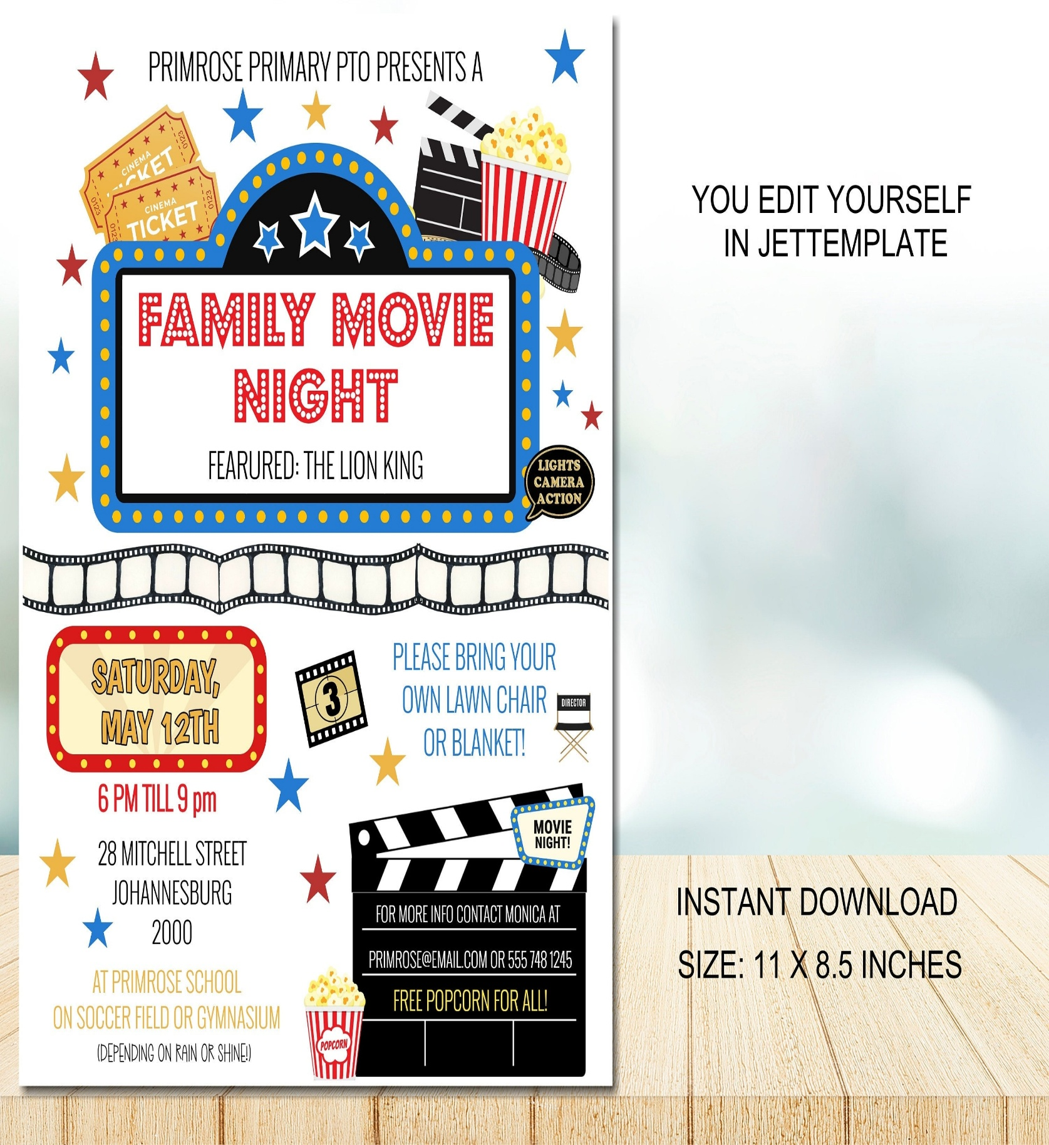

Zoom info:

[*https://us02web.zoom.us/j/83096366206?pwd=J7wZ8bwAcBA1snP5SgRuYhW4E2DsU.1*](https://us02web.zoom.us/j/83096366206?pwd=J7wZ8bwAcBA1snP5SgRuYhW4E2DsU.1)

*Meeting ID:  830 9636 6206*

*Passcode: 199366*

***To use your cell phone or land line, please dial:***

***1. 301. 715. 8592***

*Meeting ID:  830 9636 6206#*

Movie Night

Sometimes Young Adult Ministry is challenging, and we need to “turn the other cheek” and persevere with God’s help!!!!

Friday, September 19th

7:00 P.M. via Zoom

All Are Welcome!!!!

**BETHESDA BAPTIST CHURCH**

**CHRISTIAN EDUCATION MINISTRY**

**INVITES YOU TO:**

**MOVIE NIGHT**

**FEATURE: “PLAY THE FLUTE”**