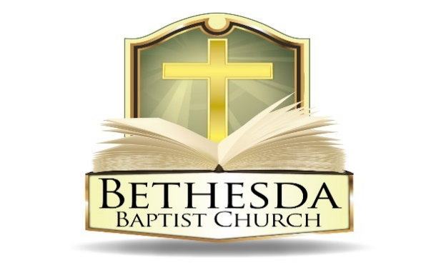
Covenant Partner News
Sunday, June 29, 2025
Volume 5 Issue 26

RECURRING EVENTS

Hour of Power & Bible Study Tuesday Bible Study will resume in the Fall.
Each Tuesday at 6:00pm followed by Bible Study at 7:00pm via *ZOOM:
https://us02web.zoom.us/j/83096366206?pwd=J7wZ8bwAcBA1snP5SgRuYhW4E2DsU.1
Meeting ID: 830 9636 6206 Passcode: 199366
To use your cell phone or land line, *please dial: 1. 301. 715. 8592
Meeting ID: 830 9636 6206#; Passcode: 199366#
We encourage all members to submit prayer requests as the Holy Spirit leads by 12:00 Noon on Monday.

Open Praise Forum & Bible Study Tuesday Bible Study will resume in the Fall.
Every Tuesday leading up to Communion Sunday at 6:00pm followed by
Bible Study at 7:00pm via ZOOM and on conference line referenced above. *

Bible Study Young Adult Edition
Each Wednesday at 7:30pm EST and 6:30pm CST via Zoom.
Register by text at 202-262-4476 or email kgoady07@gmail.com.

Men’s Prayer Hour
Each Wednesday at 9:00pm via conference call: 1.717.908.1972; Access 875378#

Women’s Prayer Hour Women’s Prayer Hour will resume in August.
Each 4th Saturday at 9:00am via conference call: 1.605.313.5143; Access code 654522#

Questions and Answers
Held each 4th Sunday at 6:00pm via conference call: 1.717.908.1972; Access code 875378#
Please submit your questions today by email to: SoulCare@Bethesdaweb.org or in Q&A box located on the table outside of the church office.

Bible Study Thursday Bible Study will resume in the Fall.
Each Thursday at 12:00 Noon via conference call: 1.717.908.1972; Access code 875378#

THIS WEEK EVENTS

Saturday, July 5
10:00am DC Aglow Ministry, Room 128

ANNOUNCEMENTS

EOU Planning Session 6:30pm Monday, July 7
Christian Education Meeting 6:30pm Thursday, July 10 via conference call
Fellowship in the Park Date scheduled for July 12th is postponed.

SUNDAY SCHOOL
Please be advised that there will be no Sunday School this Sunday.

CAMP INSPIRE
We were informed on Thursday that for reasons outside of our control, the funding for the 8-week summer camp has been withdrawn. This was unexpected. We thank you Bethesda for your prayers and a special thank you for all who worked diligently to make this happen. There will be no summer camp this year. God's plans are perfect and bigger than our plans!

EDUCATION SUNDAY
“We’re excited to celebrate Honorees today, Sunday June 29th, a special time to recognize the accomplishments and milestones of our church family! Whether you’ve graduated, started a new job, welcomed a new baby, purchased a home, or reached another meaningful achievement—we want to celebrate with you!

Let’s come together and honor God’s blessings and encourage one another through every season of growth and success. We look forward to celebrating with you!”

BETHESDA BAPTIST CHURCH WOMEN’S MINISTRY
Capitol Hill Pregnancy Center Bottle Mission Project

“Behold, children are a heritage from the LORD, the fruit of the womb a reward.” Psalm 127:3
The women's planning committee would like to thank the entire Bethesda Family for participating in the baby bottle project. The donations will be a blessing to assist with needed supplies for the Capitol Hill Pregnancy Center.

There is still time to return the baby bottles with your donations as donations of any size will be a blessing!

A little change……CHANGES LIVES!

ANNOUNCEMENTS CONTINUED:

CHILD EVANGELISM FELLOWSHIP 5-DAY CLUB DRIVERS
5 Day Club” Summer Ministry, sponsored by Child Evangelism Fellowship of the Greater Washington DC Metro Area, Inc., is looking for dedicated individuals to transport our Christian Youth in Action (CYIA) workers to various sites in the Metropolitan Washington DC Area.

This is a short-term voluntary position during the month of July, which supports our CYIAers in ministering to youth ages 5 to 12 years old. Volunteers can choose from various dates and hours/times to serve according to their availability. If interested, call the church at 202-635-2883.

