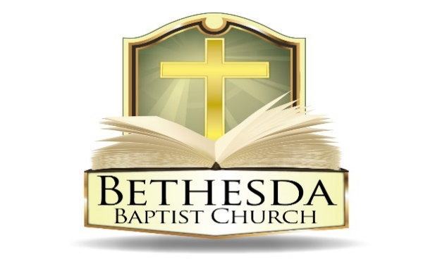
Covenant Partner News
Sunday, June 22, 2025
Volume 5 Issue 25

RECURRING EVENTS

Hour of Power & Bible Study Tuesday Bible Study will resume in the Fall.
Each Tuesday at 6:00pm followed by Bible Study at 7:00pm via *ZOOM:
https://us02web.zoom.us/j/83096366206?pwd=J7wZ8bwAcBA1snP5SgRuYhW4E2DsU.1
Meeting ID: 830 9636 6206 Passcode: 199366
To use your cell phone or land line, *please dial: 1. 301. 715. 8592
Meeting ID: 830 9636 6206#; Passcode: 199366#
We encourage all members to submit prayer requests as the Holy Spirit leads by 12:00 Noon on Monday.

Open Praise Forum & Bible Study Tuesday Bible Study will resume in the Fall.
Every Tuesday leading up to Communion Sunday at 6:00pm followed by
Bible Study at 7:00pm via ZOOM and on conference line referenced above. *

Bible Study Young Adult Edition
Each Wednesday at 7:30pm EST and 6:30pm CST via Zoom.
Register by text at 202-262-4476 or email kgoady07@gmail.com.

Men’s Prayer Hour
Each Wednesday at 9:00pm via conference call: 1.717.908.1972; Access 875378#

Women’s Prayer Hour Women’s Prayer Hour will resume in August.
Each 4th Saturday at 9:00am via conference call: 1.605.313.5143; Access code 654522#

Questions and Answers
Held each 4th Sunday at 6:00pm via conference call: 1.717.908.1972; Access code 875378#
Please submit your questions today by email to: SoulCare@Bethesdaweb.org or in Q&A box located on the table outside of the church office.

Bible Study Thursday Bible Study will resume in the Fall.
Each Thursday at 12:00 Noon via conference call: 1.717.908.1972; Access code 875378#

THIS WEEK EVENTS

Sunday, June 22
9:30am Dedication of VBS Volunteers
9:30am Church Meeting
6:00pm Questions and Answers Sunday, via zoom (same as Tuesday prayer zoom lines)

Monday - Friday, June 23-27
6:00pm Vacation Bible School (VBS)

Wednesday, June 25
10:00am Homegoing Services

Saturday, June 28
10:30am VBS Closing Program

ANNOUNCEMENTS

Education Sunday 9:30am Sunday, June 29
Camp Inspire 8 :30am- 4:00pm Monday, June 30 – August 15
EOU Planning Session 6:30pm Monday, July 7

CHURCH MEETING
There will be a meeting after worship service today, Sunday, June 22 to brief the church and seek approval for an expanded Summer Day Camp, Monday, June 30 to Friday, August 15, 2025.

2025 JOHN D. BUSSEY SCHOLARSHIP
2025 Church Scholarship Applications Are Now Available! We're excited to share that the 2025 John D. Bussey Scholarship application is now open to members of our congregation. IF you are pursuing higher education, we encourage you to apply. Applications are due by June 22, 2025. Applications can be found outside of the church office or on the church website for the application. Email johndbusseyscholarship@gmail.com for additional information.

DEDICATION OF VBS WORKERS
Please pray for God's blessings on our upcoming VBS and Summer Day Camp as the start dates for these programs draw nearer. We will have a dedication of VBS workers on Sunday, June 22.

PRAYER MEETING CANCELED
Due to VBS on Tuesday, June 24th there is no prayer meeting. We will resume on Tuesday, July 1st.

QUESTIONS AND ANSWERS SUNDAY
On Sunday, June 22nd at 6:00 PM we will review "Juneteenth: Faith and Freedom" during our 4th Sunday Q&A time via Zoom. :
https://us02web.zoom.us/j/83096366206?pwd=J7wZ8bwAcBA1snP5SgRuYhW4E2DsU.1
Meeting ID: 830 9636 6206 Passcode: 199366
To use your cell phone or land line, *please dial: 1. 301. 715. 8592
Meeting ID: 830 9636 6206#; Passcode: 199366#

ANNOUNCEMENTS CONTINUED:

ATTENTION VOLUNTEERS AND PARTICIPANTS
Just a reminder! The time is drawing near. It’s Vacation Bible School Time! Are you ready? Have you signed up to volunteer? We need you to sign up today. Please stop by the table in the vestibule today and sign up for Vacation Bible School, June 23-28, 2025. Someone is in the vestibule to provide information and sign up; or click here to register: VBS Volunteer ; or
VBS Student Participant . You don’t want to miss this opportunity!
O magnify the Lord with me! Let us exalt His name together!

EDUCATION SUNDAY
“We’re excited to celebrate Honoree Sunday on June 29th, a special time to recognize the accomplishments and milestones of our church family! Whether you’ve graduated, started a new job, welcomed a new baby, purchased a home, or reached another meaningful achievement—we want to celebrate with you!

If you or someone in your household has something to be recognized, please submit your name and accomplishment via email to (erikathompson23@gmail.com) or to the church office by June 22.

Let’s come together and honor God’s blessings and encourage one another through every season of growth and success. We look forward to celebrating with you!”

CHILD EVANGELISM FELLOWSHIP 5-DAY CLUB DRIVERS
5 Day Club” Summer Ministry, sponsored by Child Evangelism Fellowship of the Greater Washington DC Metro Area, Inc., is looking for dedicated individuals to transport our Christian Youth in Action (CYIA) workers to various sites in the Metropolitan Washington DC Area.

This is a short-term voluntary position during the month of July, which supports our CYIAers in ministering to youth ages 5 to 12 years old. Volunteers can choose from various dates and hours/times to serve according to their availability. If interested, call the church at 202-635-2883.

ANNOUNCEMENTS CONTINUED:

CONVOY OF HOPE
Bethesda is grateful for the donations from Convoy of Hope on June 7th Community Day. They are a ministry that allowed us to provide free food, sneakers and socks to all in attendance. The left-over items have been placed in our pantry so we can continue to meet the needs of our community. Bethesda did not have to bear the cost for these items. If you would like to make a donation (any amount) to help cover expenses for all the resources that were provided from Convoy of Hope, you can do so at this link: https://unityweekend.com/donate/

