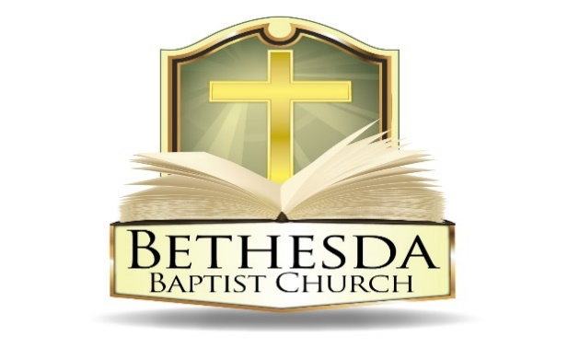
Covenant Partner News
Sunday, May 18, 2025
Volume 5 Issue 20

RECURRING EVENTS

Hour of Power & Bible Study
Each Tuesday at 6:00pm followed by Bible Study at 7:00pm via *ZOOM:
https://us02web.zoom.us/j/83096366206?pwd=J7wZ8bwAcBA1snP5SgRuYhW4E2DsU.1
Meeting ID: 830 9636 6206 Passcode: 199366
To use your cell phone or land line, *please dial: 1. 301. 715. 8592
Meeting ID: 830 9636 6206#; Passcode: 199366#
We encourage all members to submit prayer requests as the Holy Spirit leads by 12:00 Noon on Monday.

Open Praise Forum & Bible Study
Every Tuesday leading up to Communion Sunday at 6:00pm followed by
Bible Study at 7:00pm via ZOOM and on conference line referenced above. *

Bible Study Young Adult Edition
Each Wednesday at 7:30pm EST and 6:30pm CST via Zoom.
Register by text at 202-262-4476 or email kgoady07@gmail.com.

Men’s Prayer Hour
Each Wednesday at 9:00pm via conference call: 1.717.908.1972; Access 875378#

Women’s Prayer Hour
Each 4th Saturday at 9:00am via conference call: 1.605.313.5143; Access code 654522#

Questions and Answers
Held each 4th Sunday at 6:00pm via conference call: 1.717.908.1972; Access code 875378#
Please submit your questions today by email to: SoulCare@Bethesdaweb.org or in Q&A box located on the table outside of the church office.

Bible Study
Each Thursday at 12:00 Noon via conference call: 1.717.908.1972; Access code 875378#

THIS WEEK EVENTS

Monday, May 19
10:00am Visitation followed by Celebration of Life Memorial Service
7:00pm Women's Ministry Planning Team Meeting, call: 1.605.313.5143; Access code 654522#

Tuesday, May 20
11:00am Deaconess Ministry Meeting, in person

Thursday, May 22
7:00pm Community Day Orientation & VPop Screening in person

Saturday, May 24
9:00am Women's Ministry Prayer Hour, call: 1.605.313.5143; Access code 654522#
10:00am Food and Clothing Distribution
11:30am Combined Choir Rehearsal, Room 120

ANNOUNCEMENTS

Question & Answer Sunday 6:00pm Sunday, May 25
Seniors’ Ministry Meeting 11:00am Wednesday, May 28
Deaconess Board Ministry Meeting 6:30pm Wednesday, May 28
Voices of Bethesda Business Fellowship 6:30pm Wednesday, June 4
Community Day 10:30am Saturday, June 7

QUESTIONS & ANSWERS
The next Q&A session will be Sunday, May 25. We encourage you to submit questions by the 2nd Sunday of each month from your personal study of God's Word if you have any. Please submit your questions today by email to: SoulCare@Bethesdaweb.org or in Q&A box located on the table outside of the church office. We can all learn from each other!

SHARING GOD'S WORD – GIVE NEW LIFE TO YOUR UNUSED BIBLE
Many of us are blessed to own more than one Bible, and today we have a special opportunity to use this blessing for a greater purpose. We are asking our members to donate gently used NKJV (only) Bibles that can serve as instruments of hope, guidance, and faith in our community outreach efforts.

To ensure the donated Bibles are ready to be shared with the community, we kindly ask that they meet the following guidelines:"

• No torn pages
• No watermarks
• No excessive notes
• Blot out any personal information

These Bibles will be shared during witnessing events to reach those seeking spiritual direction or simply needing to hear God's Word.

Let us come together in the spirit of generosity and mission, helping spread God’s love through His Word. Your contribution can make a profound difference in someone's life, planting seeds of faith and drawing hearts closer to Him.

If you have a gently used NKJV Bible (only) to donate, please place it in the designated bins located outside the sanctuary May 25. Thank you for contributing to this meaningful initiative and helping share God’s love with the community."
ANNOUNCEMENTS CONTINUED:

SENIOR’S MINISTRY
The Senior’s Ministry will host Ms. Rosalyn Morgan, author of “Laughing to Keep From Crying, This Alzheimer’s Thing is No Joke.” Her book was turned into a play in 2018. Ms. Morgan will be speaking regarding support for care givers. There will be a question-and-answer period. Light refreshments will be served.

The meeting will be held in the Fellowship Hall on Wednesday, May 28, 2025, at 11am. Looking forward to seeing you.

SUNDAY SCHOOL
“Do you want to draw closer to God and learn all the many benefits that come from valuing, meditating, and applying His word to your daily life? Then come join the Sunday school starting in June as we take a deep dive into psalm 119. Books for the class will be available for pick up in room 120, on the 4th Sunday in May after Sunday school. Come out and join our small group study at church or online as we seek to become more like Jesus. Thanks for your support.”

COMFORT MINISTRY – A CALL TO SERVE
"Comfort ye, comfort ye, my people, saith the Lord." – Isaiah 40:1

The Comfort Ministry of Bethesda Baptist Church is dedicated to providing prayer, consolation, and support to our bereaved members. As we revive this vital ministry, we invite compassionate individuals to join us in serving those in their time of need.

By becoming a part of this ministry, you will not only bring comfort to others but also experience the joy and fulfillment that comes from serving.
If you feel called to this mission, we would love to have you join us. For more information, please contact Sis. LaVerne Brown or Sis. Margaret Elliott.

TRANSPORTATION MINISTRY
The Transportation Ministry needs Drivers and Chaperones for the church van, as well as volunteers to carpool members to church. If you need a ride, please contact the church office at 202-635-2883. You may also contact Sis. Jessica Reid (202-706-2211) up until 6pm on Saturday's if a ride is needed for the upcoming Sunday.

ANNOUNCEMENTS CONTINUED:

WORSHIPING NURSERY
Praise the Lord Bethesda! On Sundays, during the 9:30 am Worship Service, the Worshiping Nursery is open to receive children ages 1 year (must be walking) to 5 years old, where children can learn about the Lord on their own level. Parents should feel free to take their children to the Nursey and return to worship service. We are still in need of volunteers and your prayers to ensure that we can sustain service in the Nursery. Pray that the Lord will use you and volunteer as a worker. Please contact Sister Denise McPayten-Nedab at 202-306-2420.

