Bethesda Baptist Church
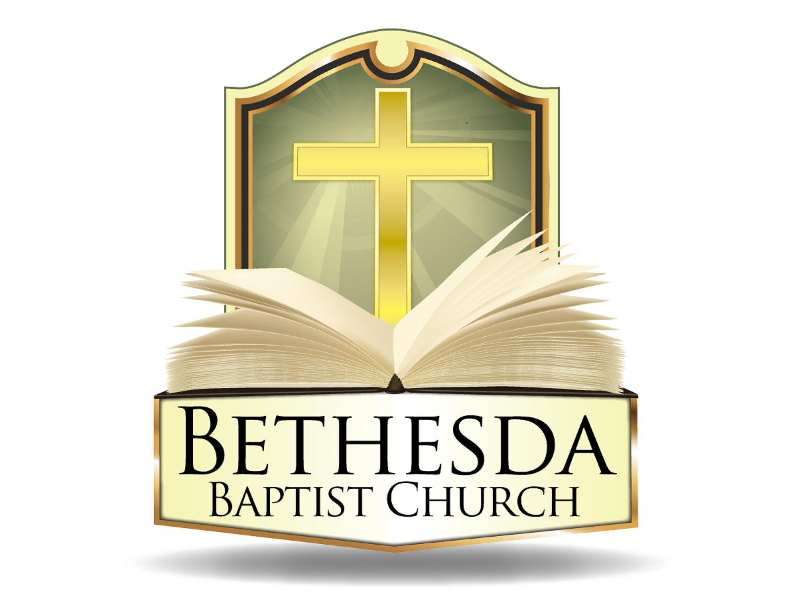
John D. Bussey Scholarship Application

Application Due Date is May 26th, 2024 @ 1pm

Contacts: Sister Erika Thompson (Chair), Sis. Jennie Sanders and Sis. Tigist Ashaka
John D. Bussey Scholarship Committee
johndbusseyscholarship@gmail.com

Criteria for Eligibility
(Article VI of the John D. Bussey Scholarship Committee Bylaws)

Section A. The applicant must be a member of Bethesda Baptist Church having been united with the church not less than two consecutive years.
Section B. The Applicant must demonstrate financial need based on specific financial documentations and specific records of scholastic achievement for merit.
Section C. The applicant must submit completed scholarship forms, two letters of recommendation and other required documents to the JDB Scholarship Review Committee. One letter of recommendation must come from the leader, sponsor or coordinator of a Bethesda Ministry in which the applicant participates or has participated.
Section D. The applicant must show proof of enrollment in a college, university, vocational school, or for a post high school education program¹.
Section E. The applicant and parent/guardian must be available for interview at the church at a time designated by the scholarship review committee.
Section F. The committee shall notify the applicant of results.
Important Notice to Applicants!!
(Failure to comply with any of the items listed in the criteria above and the instructions below will result in disqualification of the application.)
- The application deadline is May 26, 2024 at 1:00 PM. The deadline must be met. There will be no exceptions. Completed applications may be emailed, submitted at the church, or sent via postal mail.
  - If emailing the application, Completed application packages may be signed and e-mailed to johndbusseyscholarship@gmail.com by the application deadline. Be sure to scan and include all materials in one email titled “2024 John D. Bussey Scholarship Application.”
  - If submitting the application at Bethesda Baptist Church, place applications in the box marked as “John D. Bussey Scholarship” located at the table outside the office.
  - If mailing the application, it must be addressed to Bethesda Baptist Church, 1808 Capitol Ave NE, Washington DC 20002; and postmarked no later than May 22nd. The application should be addressed to the John D. Bussey Scholarship Committee.
- All information on the application must be filled out completely.
- When N/A (not applicable) is used in response to any of the questions, please provide a brief explanation as to why.
- If you cannot make the scheduled interview, you are expected to notify the Chair within 24 hours prior to your appointment. If you do not appropriately cancel and reschedule, the application will be disqualified.
- The application must be signed.
Applicants, we urge you to ask questions BEFORE you submit your applications.
¹ We understand you may not have this information during the application/interview process; however, you must have it in order to receive your award

General Information
Legal Name
Mailing Address
Telephone | ( ) |  | E-mail address |  | Birth Date | / /
Are you a member of Bethesda Baptist Church? □ Yes □ No  (To apply, Bethesda membership for two consecutive years is required) |  |  |  |  | Number of Years
Please mark in the appropriate box
Academic Information
(Your most recent transcript/grades MUST accompany your application)
Name and address of High School | Year graduated / will graduate  ____/_ _/_ _
List higher education institution(s) you have attended | Hours achieved  Degree received
Name and address of higher education institution where you have been accepted to attend 2024-2025
Fall [ ]
Spring [ ]

First-time applicant
Returning applicant

Do you plan to attend full time?  □ Yes □ No | Degree Expected | Field of study | Year of study (class level) | Cumulative grade point average (GPA)

Financial Information
Mother / Legal Guardian’s Name | Father / Legal Guardian’s Name
Mother / Legal Guardian’s Address | Father / Legal Guardian’s Address
(1) Anticipated Annual Academic Expenses  (What will total cost be?) | (2) Education Resources  (How much do you have or expect?)
Tuition……………………………………………………….$  Room and Board ……………………………………….$  Books ………………………………………..……………...$  Other (please specify) …………………………...….$  Total Annual Funding Required ………………….$ | Parent(s) / Legal Guardian(s)  Contribution ………………………………..$  Loans (specify type) ……………………..$  Grants (specify type) ……………………$  Other sources of financing  Education …………………………………….$
(3) How much funding do you still need?  (What do you need?)  Place the net amount here that represents the Annual Academic Expenses (1) less your Education Resources (2)  $ | Do you work?  Yes  No | If yes, type of work | Annual Income  $
 | How much will you contribute towards your education? |  | $
 | Total Resources  (Education Resources plus Work) |  | $

Work Experience
Year | Place of Employment | Job Title | Explanation of duties

Extracurricular and Volunteer Activities
(church, school, community, etc.)
Year | Type of Activity | Please note any special positions or recognition received

Special Professional or Scholastic Honors
Year | Type of Honor | Brief description of what you did to receive it

Essay
Please choose one of the below essay prompts. The essay must be at least two pages in length, typed, double spaced and in 12-point font.
- Describe the journey of nurturing and preserving your faith. Reflect on moments when you felt lost, akin to the parable of the lost sheep or the prodigal son, and how you found your way back to God’s guidance.
- There is a TikTok prompt that asks people how and when they realized God is real. Share a personal anecdote that exemplifies your belief in God’s presence and His intervention in your life. Consider instances where you’ve experienced profound moments of reassurance or clarity, and elaborate on how these experiences have affirmed your faith.
- When you pack your luggage for college, will you pack your faith? Explore the significance of integrating faith into your college experience. Discuss how you will prepare spiritually for this new chapter, contemplating the ways your faith influences your choices, relationships, and pursuits amidst the academic and social landscape of college life.
Take this essay seriously! Plagiarism, failure to attribute factual statements and padding will detract from your overall scholarship application and award amount.

Your signature indicates that all of the information included in this application is true and accurate.
(Parent/guardians signature required if applicant is under 21 years of age)

Date Applicant’s Signature

Date Parent/Guardian Signature

2024 Scholarship Checklist
Before you submit your application, please review and confirm that you have met all of the following requirements.

Please place a check beside each directive that you have met.
- I have been a member of Bethesda Baptist Church for at least two consecutive years.
- My most recent transcript or grades are attached.
- I have at least two separate letters of recommendation attached. One letter of recommendation is from a Bethesda Ministry in which I serve or have served.
- I have attached my typed, double-spaced, 12-point-font essay of at least two pages in length on the topic provided.
  - Check for misspellings
  - Used correct capitalization and punctuation
  - Have used complete sentences that flow to give ideas
  - Used correct and consistent tense throughout the essay
  - Have properly referenced any cited quotations or information used
- I have completed the John D. Bussey Scholarship Application in its entirety with no omissions.
- I have met the 05/26/2024 deadline.

Please Note:
If any of the above requirements are NOT met, your application will be disqualified. Also, we understand that proof of enrollment may not be available during the application/interview process; however, it is required in order for you to receive an award. It is imperative that you forward this information to the scholarship committee(johndbusseyscholarship@gmail.com) or another member of the scholarship committee as soon as you get it.

Examples of acceptable Proof of Enrollment:
First-time Students | - Acceptance letter  - Tuition bill
Returning Students | - Tuition bill  - Registration schedule from the school with the student’s name on it  - Letter from school stating that you are a student in good standing

Name of Applicant:

Signature of Applicant:

Date:

